Temogo Masuku

6 October 2025   ST10461592

CLDV6212 POE PART 2

**GITHUB LINK**: https://github.com/IIEWFL/cldv6212-part-2-ST10461592-Temogo-Masuku#

**Function App LINK**: <https://st10461592function.azurewebsites.net>

**Web App Link:** https://abcretail20251006203524-ajepcre4cxh4gdar.southafricanorth-01.azurewebsites.net

**SCREENSHOTS:**

**Screenshot of Table storage**

**Screenshot of the customer container:**

**Screenshot of the product container:**

**Screenshot of Queue Storage:**

**Screenshot of File Share Storage:**

**Screenshot of Blob Storage:**

**Screenshot of customer photos container:**

**Screenshot of product photos container:**

**Screenshot of function app deployment:**

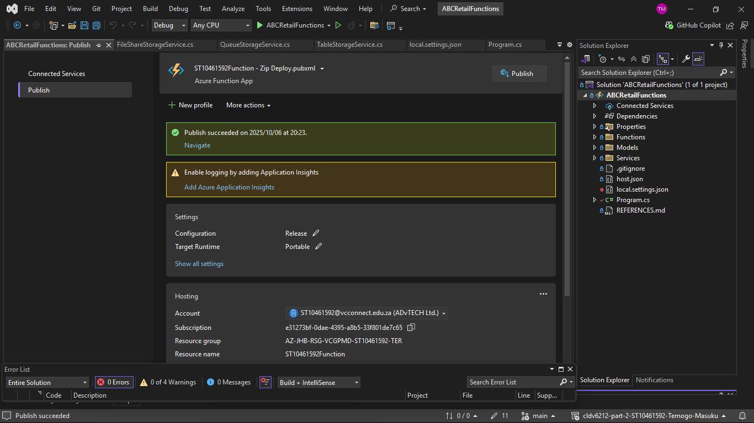

**Screenshot of Web app deployment:**

**THEORY:**

Azure Event Hubs and Azure Event Bus are crucial services that can greatly improve applications' user experiences. Azure Event Hubs facilitates real-time data processing by acting as a highly scalable data streaming platform and event ingestion service. Businesses can analyse customer interactions quickly by ingesting events as they happen. This allows them to respond to customer needs immediately, increasing customer satisfaction and engagement. Users' trust is increased by its scalability, which guarantees that apps stay responsive during busy periods. Furthermore, Event Hubs easily connects with other Azure services, making data analysis easier and allowing companies to customize client interactions. Data retention also makes historical analysis possible, which enhances future interactions by revealing insights into customer behaviour. (Turbo360, n.d.)

Azure Event Bus, also known as Azure Service Bus, on the other hand, improves communication within applications by enabling asynchronous messaging between various components. More flexibility and scalability are made possible by this decoupling of services, guaranteeing effective request processing without downtime. In order to ensure a seamless customer experience, particularly during transactions, the Event Bus ensures dependable message delivery and retains messages until they are successfully processed. It also facilitates smooth communication between microservices, which makes it possible for functions like order processing and customer service to work together harmoniously and provide customers with timely updates. Businesses can release features and make improvements more quickly by putting in place an event-driven architecture, which enables them to react to customer needs and feedback more quickly. (ThirdEye Data, n.d.) (Softweb Solutions, 2023)

In conclusion, scalability, dependable communication, and real-time data processing enable both Azure Event Hubs and Azure Event Bus to significantly enhance the customer experience. Their application may result in a more individualized, effective, and responsive customer experience, which will eventually increase client happiness and loyalty. (Dev4Side, n.d.) (NDC Conferences, 2024)

# Bibliography

Dev4Side, n.d. *Azure Service Bus: an introductory guide.* [Online]   
Available at: https://www.dev4side.com/en/blog/azure-service-bus  
[Accessed 4 October 2025].

Softweb Solutions, 2023. *Azure Event Hub vs. Azure Service Bus: A comprehensive comparison.* [Online]   
Available at: https://www.softwebsolutions.com/resources/azure-service-bus-vs-event-hub.html  
[Accessed 4 October 2025].

ThirdEye Data, n.d. *Azure Event Hub: Explanation, Guide & Insights by ThirdEye Data.* [Online]   
Available at: https://thirdeyedata.ai/azure-event-hub/  
[Accessed October 4 2025].

Turbo360, n.d. *Azure Event Hubs and its Complete Overview.* [Online]   
Available at: https://turbo360.com/guide/azure-event-hub  
[Accessed 4 OCtober 2025].

NDC Conferences (2024). Azure Messaging, Queueing, and Events - Which service is right for your solution? - Brian Gorman. [online] YouTube. Available at: https://www.youtube.com/watch?v=vCeIlEhHF5Y [Accessed 4 Oct. 2025].